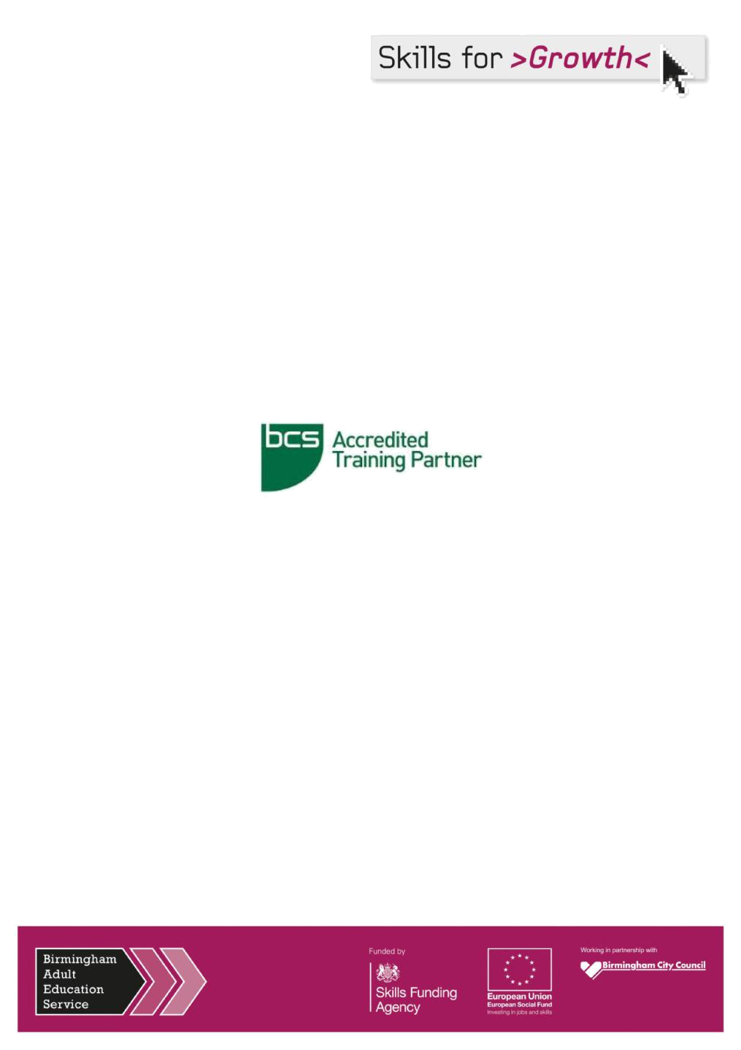

BCS Foundation in

Business Analysis - Online

Information Pack & Application Form

Business Analysis – Foundation Certificate

What do Business Analysts do? What skills and competencies do they require to do their role? This Foundation level course provides delegates with a 'whistle-stop tour' of the role of the Business Analyst who acts as the link between business needs, users and IT within change initiatives.

This BCS accredited online interactive multimedia course provides an overview of the ever important Business Analyst role, and covers the broad range of techniques used within the structure of the Business Analysis process model.

It shows the links between the Business, the users and IT, and the valuable contribution the Business Analyst makes and the tools and techniques they have at their disposal.

The BCS Business Analysis Foundation certificate is relevant to anyone requiring an understanding of Business Analysis including business analysts, business managers and their staff, business change managers and project managers.

The accredited e-learning will cover everything you need to pass the Foundation exam first time.

This Business Analysis Foundation course offers learners:

- Online access to the accredited multimedia e-learning course for one whole year (approx. 18 hours of study time)

- Business Analysis Third edition book

- Interactive quizzes and mock exam simulators to test knowledge ahead of the exam

- Access to qualified experts around the globe

Course Overview

You can undertake the course and prepare thoroughly for the BCS accredited exam, all at your own pace and from any location.

- Fully interactive course structure enables you to learn at your own pace
- Comprehensive and detailed course content
- Written by experienced BCS examiners
- Questions on all sections of the course allow you to regularly reinforce your learning

- Recorded tests at the end of each module let you compare your results in your online gradebook

- Access to further online reading on each module of the course to strengthen knowledge
- Advice, hints and tips on learning and how best to prepare for the exam
- Assistance from experienced tutors if required

Intended Audience

The certificate is relevant to those individuals, maybe in different disciplines such as project management or systems development, requiring a high level understanding of the role of the Business Analyst. It can also be useful for Business Managers and their staff who want to gain an understanding of Business Analysis. Anyone who requires an understanding of Business Analysis including business analysts, business managers and their staff, business change managers and project managers.

It is also suitable for those who are considering a career change to become a business analyst and who would like to understand more about the role.

Course Objectives

Candidates should be able to demonstrate knowledge and understanding of business analysis principles and techniques. Key areas are:

- The role and competencies of a business analyst

- Strategy analysis
- Business system and business process modelling

- Stakeholder analysis
- Investigation and modelling techniques

- Requirements engineering
- Business case development

How long does the course take to complete?

The course lasts approximately 18 hours.

What does the online course cover?

- What is Business Analysis?

  - The rationale for business analysis
  - The development of business analysis
  - The scope of business analysis
  - The role and responsibilities of a business analyst

- The Competencies of a Business Analyst

  - The Business Analysis Maturity Model

  - The responsibilities of a business analyst
  - The competencies of a business analyst
  - The Skills Framework for the Information Age

- Strategy analysis

  - The strategic context

  - Developing business strategies

  - Strategic analysis techniques
  - SWOT analysis

  - Implementing strategy

- The Business Analysis Process Model

  - The lifecycle for business analysis

  - Creative problem-solving approach
  - Stages of the lifecycle
  - Deliverables and activities for each stage

- Investigation techniques

  - Interviewing and workshops
  - Observation approaches
  - Scenarios and prototyping
  - Quantitative investigation techniques
  - Documenting business situations

- Stakeholder analysis and management

  - Categorising stakeholders
  - Analysing stakeholders
  - Stakeholder management

- Modelling business systems

  - Soft systems methodology
  - Documenting business situations
  - Business perspectives
  - Business activity models
  - Business events and business rules
  - Performance measures
  - Gap analysis

- Modelling business processes

  - The organisational view of business processes
  - Business process modelling techniques
  - Business process improvement
- Gathering the Requirements

  - The requirements engineering process

  - Actors in requirements engineering
  - Requirements elicitation
  - Requirements analysis
  - Requirements validation

- Documenting and managing requirements

  - The importance of documentation

  - The requirements document
  - The requirements catalogue
  - Managing requirements

- Modelling requirements

  - Modelling system functions
  - Modelling system data

- Delivering the requirements

  - The context for the delivery approach
  - The waterfall lifecycle
  - The ‘V’ model lifecycle
  - Incremental delivery
  - Iterative or evolutionary systems development lifecycle

- Making a business and financial case

  - The business case in the project lifecycle
  - Identifying options
  - Assessing feasibility
  - Structure of a business case
  - Investment appraisal techniques
  - Presenting the business case
  - Realising the benefits

- Implementing business change

  - Introducing a new business system
  - The environment for change
  - Emotions and the change process

Pre-Reading

The syllabus for this course and exam is based on the BCS publication Business Analysis, Third Edition. It is strongly recommended that delegates familiarise themselves with this book before completing the online course. The headings listed in the syllabus relate to the relevant chapter headings, section headings and text included in this publication. The Business Analysis book can be collected from Southside Business Centre.

Examination Details

The Foundation Certificate in Business Analysis exam is to be taken on the date given via your confirmation email. The exam fee is included in the costs. The format of the examination is a one hour multiple-choice examination consisting of 40 questions. The examination is closed book (no materials can be taken into the examination room). Candidates need to achieve a minimum of 26 marks out of 40 to pass the examination. Candidates who are awarded a pass for the examination are awarded the BCS Foundation Certificate in Business Analysis.

Bytesize learners will benefit from the exam simulator included with their e-learning, helping you to re-enforce your knowledge before sitting the final exam by completing the interactive quiz after each session and the mock exam quizzes at the end of the course. This will significantly enhance your understanding of the method.

What can I do next?

You can study other BA Foundation certificates, progressing to Practitioner level. These certificates are ideal for working towards the BCS International Diploma in Business Analysis.

From HR: Retention of Services and Repayment of Financial Assistance

Financial support to undertake Business Analysis course is conditional upon employees remaining in the service of the Council for two years from the date upon which they gain the qualification or complete the course of study, whichever is the later.

Repayment of all the financial assistance made to the individual will be required if:

- the employee discontinues a course at his/her own request

- the employee fails to show satisfactory progress

- the employee leaves Council employment while undertaking a course

- the employee leaves Council employment within two years from the date on which the qualification was obtained/course was completed whichever was the later.

The Head of Service may, at their discretion, waive this rule under exceptional circumstances. Repayment of fees will not be required if employment ceases due to the following:
- Redundancy or ill health retirement

- Leave to take up another post within another Council

- Leave two years after the qualification was obtained/course was completed whichever was the later.

Employees who are liable to repay the financial assistance must liaise promptly with their line manager and HR to agree how and when it should be repaid. Any agreed repayment plan will not exceed 2 years.

The individual will then receive an invoice from Birmingham City Council. If payment instalments have been agreed, the Finance team will set up a standing order as per agreed arrangements. Failure to arrange payment instalments will result in an invoice for the outstanding fees to be paid in full.

The above conditions apply to individuals on temporary contracts with the exception that should their contract come to its contractual end date, no fees will be repayable.

Applicant’s Signature

I agree to the conditions outlined in the ‘Retention of Services and Repayment of Financial Assistance’ section of the Information Pack

 | Signature |  | Date

What Should I Do Next?

Complete the attached application form and return it to: sameena.asmat@birmingham.gov.uk

 | Your Details
 | Surname:
 | Forename:
 | Job Title:
 | Section/Directorate: |  |  | People |  |  | Place |  |  |  |  |  |  |  |  |  | Economy |  |  | Service Birmingham
 |  |  |  | Acivico |  |  | LEA Schools |  |  |  |  |  |  |  |  |  | BAES |  |  | Other
 | Work Address:
 | Tel No: |  |  |  |  |  |  |  |  | Fax No:
 | Work |  |  |  |  |  |  |  |  | Home
 | Email: |  |  |  |  |  |  |  |  | Email:
 | Line Manager:
 | Tel No: |  |  |  |  |  |  |  |  | Work Email:
 | BCS Foundation Certificate in Business Analysis – Online Qualification
 | £499 
 | BCS Foundation Certificate in Business Analysis - retake
 | £199 
 | Induction Dates – Select your Date
 | Friday 2nd December 2016 : 14:00 – 15:00 (exam will take place on 30/12/16 @ 1pm) |  |  |  |  |  |  |  |  |  |  |  |  |  |  |  |  |  |  |  | 
 | Friday 6th January 2017 : 12:00 – 14:00 (exam will take place on 03/02/17 @ 9am) |  |  |  |  |  |  |  |  |  |  |  |  |  |  |  |  |  |  |  | 
 | Friday 3rd February 2017 : 12:00 – 12:00 (exam will take place on 03/03/17 @ 9am) |  |  |  |  |  |  |  |  |  |  |  |  |  |  |  |  |  |  |  | 
 | Friday 3rd March 2017 : 12:00 – 14:00 (exam will take place on 31/03/17 @ 9 am) |  |  |  |  |  |  |  |  |  |  |  |  |  |  |  |  |  |  |  | 
 | Friday 7th April 2017 : 10:00 – 12:00 (exam will take place on 28/04/17 @ 9 am) |  |  |  |  |  |  |  |  |  |  |  |  |  |  |  |  |  |  |  | 
 | Special Requirements
 | Please state any special requirements you
 | may have whilst attending the training
 | sessions. (i.e. venue access etc.):

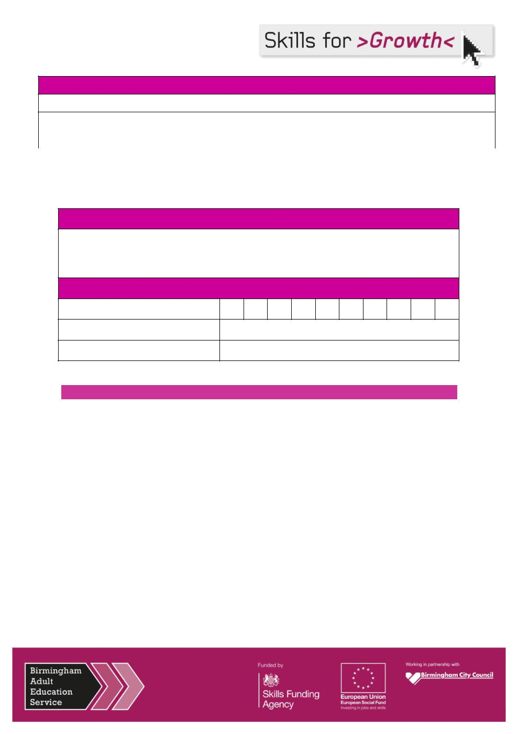
Line Manager Support Contract

I am prepared for this member of staff to take the time off, during work-time on this training:

 | Signature |  | Date

Budget Authorisation

Note: Should a candidate withdraw from the programme after official Registration with the BCS Examining Board the full costs will be taken from your budget code.

Method of Payment

Department Budget Code:

Application Authorised By:

Position of Authorised Signatory:

Return This Form To: sameena.asmat@birmingham.gov.uk

Sameena Asmat | Corporate IT Projects Leader | Birmingham Adult Education Service – Place

Directorate

Skills for Growth, Unit 23 Southside Business Centre, 249 Ladypool Road, Sparkbrook, Birmingham, B12 8LF

T: +44 (0121 675 8053) ... | M: +44 (075 2222 8644) ... |
E: sameena.asmat@birmingham.gov.uk |

